Problem 1:

Create an HBase table named 'clicks' with a column family 'hits' such that it should be able to

store last 5 values of qualifiers inside 'hits' column family.

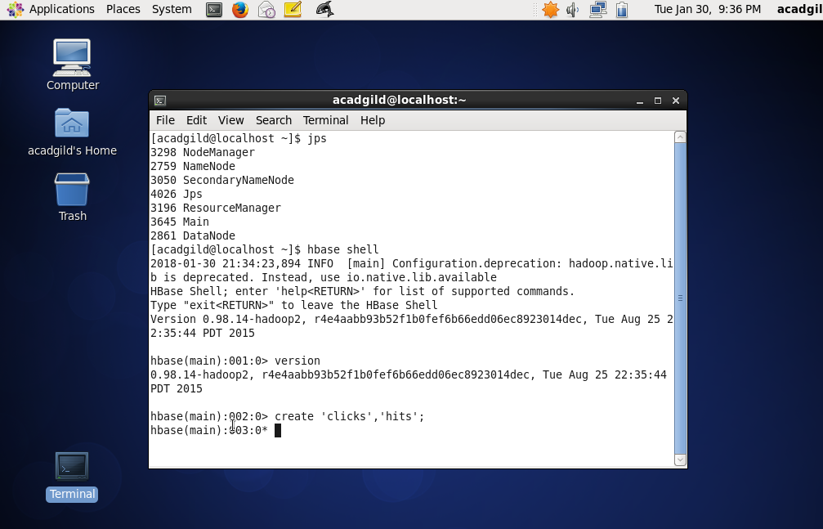

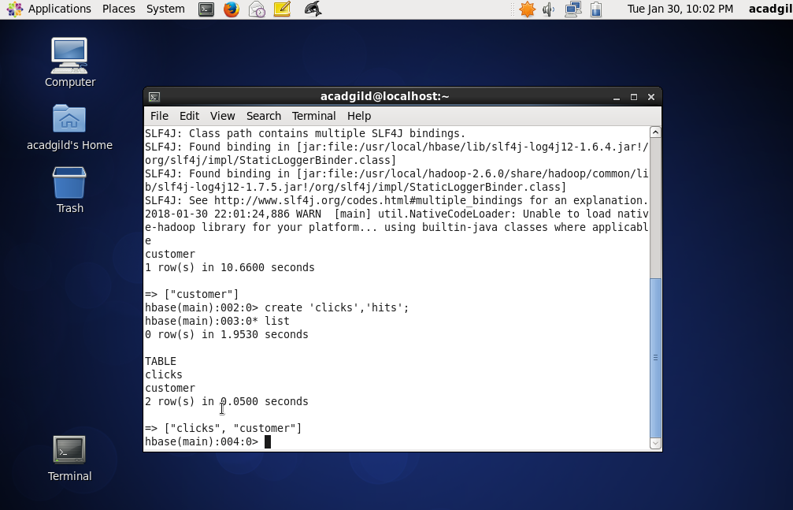

Problem 2:

Add few records in the table and update some of them. Use IP Address as row-key. Scan the

table to view if all the previous versions are getting displayed.